DBMS Lab Record Cycle

ER Diagram & Table Design
  - E-R Diagram and table reduction
  - Table descriptions

Movie database:

Table name: Directors
Description: Used to store Directors Information

Attribute | Data Type | Constraints
Id | Int | Primary Key/ Not Null
Name | Varchar2(40) | Not Null

SQL> create table Directors(Did int primary key, name varchar2(40) not null);

Table created.

SQL> desc directors;
Name Null? Type
----------------------------------------- -------- ----------------------------
DID NOT NULL NUMBER(38)
NAME NOT NULL VARCHAR2(40)

Table name: Stars
Description: Used to store Stars Information

Attribute | Data Type | Constraints
Id | Int | Primary Key/ Not Null
Name | Varchar2(40) | Unique
About | Varchar2(100)

SQL> create table stars(sid int primary key, name varchar2(40) unique, about varchar2(100));

Table created.

SQL> desc stars;
Name Null? Type
----------------------------------------- -------- ----------------------------
SID NOT NULL NUMBER(38)
NAME VARCHAR2(40)
ABOUT VARCHAR2(100)

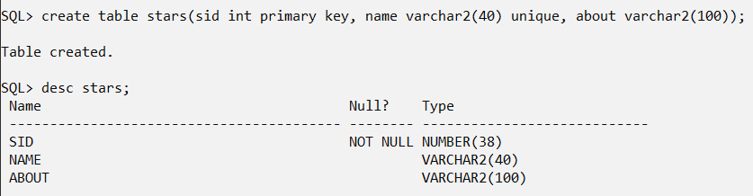

Table name: Movies
Description: Used to store Movies Information

Attribute | Data Type | Constraints
Id | Int | Primary Key/ Not Null
Title | Varchar2(40) | Not Null
R_date | Date
Image_url | Varchar2(100)
Certificate | Varchar2(20)
Runtime | Number(3,2)
ImdbRating | Number (3,1) | By default 0
Description | Text(100) | By default Null
Metascore | Number (3,1) | By default 0
Votes | Int | By default 0
Gross | Number(10,2) | Gross amount should be greater than 10000

SQL> create table movies(mid int primary key, title varchar2(40) not null, R_date date, Image_url varchar2(100), Certificate varchar2(20), Runtime Number(3,2), ImdbRating Number(3,1) Default 0, Description varchar2(100) Default NULL,Metascore Number(3,1) Default 0,Votes int Default(0), Gross Number(10,2) CHECK(gross>10000));

Table created.

SQL> desc movies
Name Null? Type
----------------------------------------- -------- ----------------------------
MID NOT NULL NUMBER(38)
TITLE NOT NULL VARCHAR2(40)
R_DATE DATE
IMAGE_URL VARCHAR2(100)
CERTIFICATE VARCHAR2(20)
RUNTIME NUMBER(3,2)
IMDBRATING NUMBER(3,1)
DESCRIPTION VARCHAR2(100)
METASCORE NUMBER(3,1)
VOTES NUMBER(38)
GROSS NUMBER(10,2)

SQL> create table movies(mid int primary key, title varchar2(40) not null, R_date date, Image_url varchar2(100), Certificate varchar2(20), Runtime Number(3,2), ImdbRating Number(3,1) Default 0, Description varchar2(100) Default NULL,Metascore Number(3,1) Default 0,Votes int Default(0), Gross int CHECK(gross>10000));

Table created.

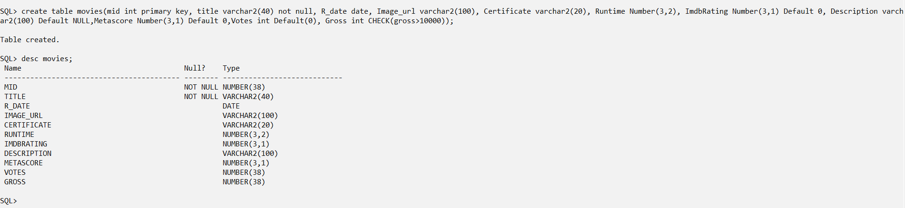

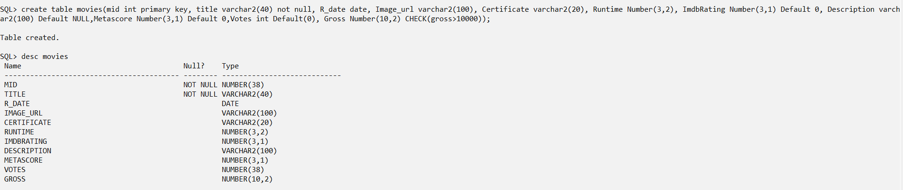

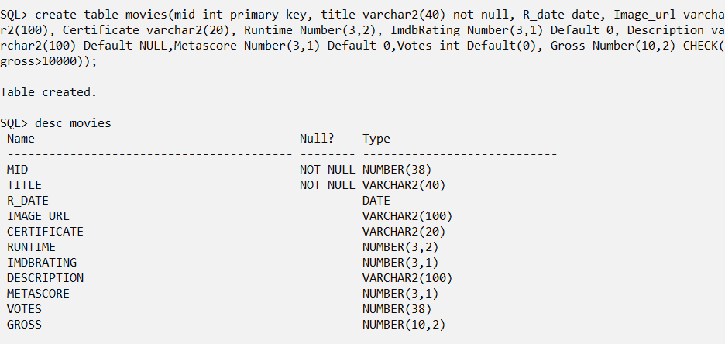

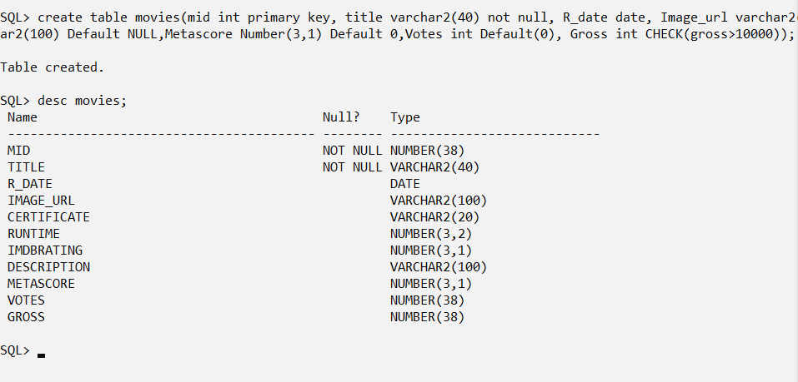
Table name: MoviesDirectors
Description: Used to store Movie Directors Information

Attribute | Data Type | Constraints
MoviesId | Int | Foreign Key references  Id of Movies table | Primary Key
DirectorsId | Int | Foreign Key references  Id of Directors table | Primary Key

SQL> create table MoviesDirectors(mid int references movies(mid), did int references directors(did),primary key(mid,did));

Table created.

SQL> desc MoviesDirectors;
Name Null? Type
----------------------------------------- -------- ----------------------------
MID NOT NULL NUMBER(38)
DID NOT NULL NUMBER(38)
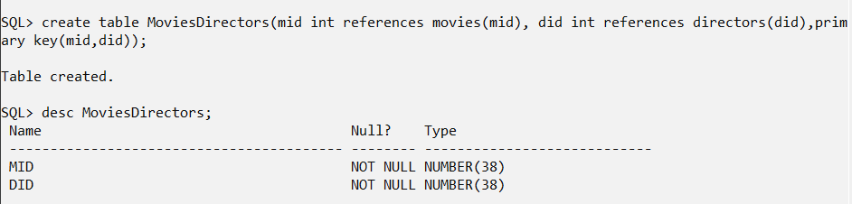

Table name: MoviesStars
Description: Used to store Movie Stars Information

Attribute | Data Type | Constraints
MoviesId | Int | Foreign Key references  Id of Movies table | Primary Key
StarsId | Int | Foreign Key references  Id of Stars table | Primary Key

SQL> create table MoviesStars(mid int references movies(mid), sid int references stars(sid),primary key(mid,sid));

Table created.

SQL> desc MoviesStars;
Name Null? Type
----------------------------------------- -------- ----------------------------
MID NOT NULL NUMBER(38)
SID NOT NULL NUMBER(38)
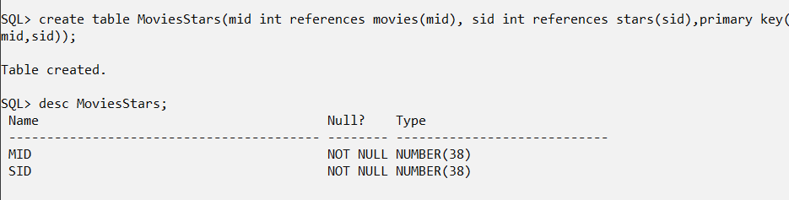des
- Practice SQL Data Definition Language(DDL) commands

- Create the tables based on the above description.
- Add a column ‘DOB’ to Stars table.

SQL> alter table stars add dob date;

Table altered.

SQL> desc stars;
Name Null? Type
----------------------------------------- -------- ----------------------------
SID NOT NULL NUMBER(38)
NAME VARCHAR2(40)
ABOUT VARCHAR2(100)
DOB DATE

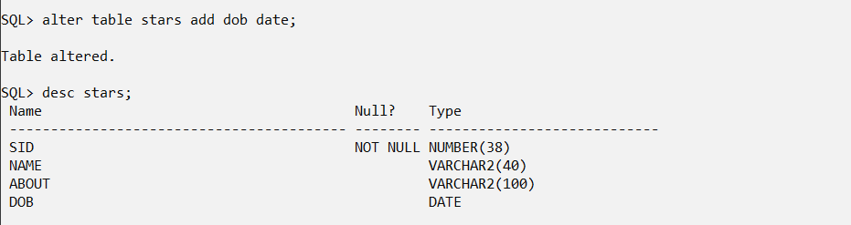
- Drop the column ‘Gross’ in Movies table.
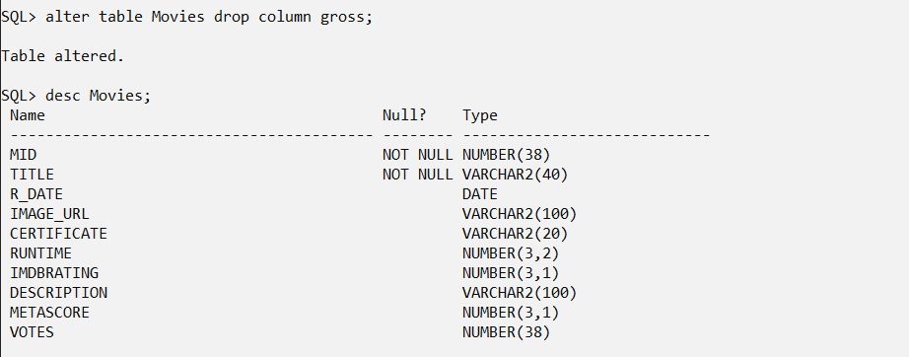

SQL> alter table Movies drop column gross;

Table altered.

SQL> desc Movies;
Name Null? Type
----------------------------------------- -------- ----------------------------
MID NOT NULL NUMBER(38)
TITLE NOT NULL VARCHAR2(40)
R_DATE DATE
IMAGE_URL VARCHAR2(100)
CERTIFICATE VARCHAR2(20)
RUNTIME NUMBER(3,2)
IMDBRATING NUMBER(3,1)
DESCRIPTION VARCHAR2(100)
METASCORE NUMBER(3,1)
VOTES NUMBER(38)

- Add column ‘Language’ in Movies table.
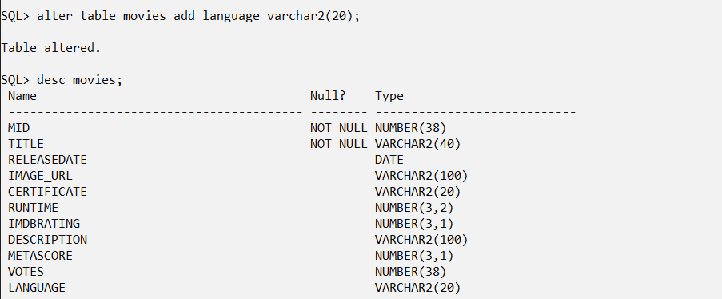

SQL> alter table movies add language varchar2(20);

Table altered.

SQL> desc movies;
Name Null? Type
----------------------------------------- -------- ----------------------------
MID NOT NULL NUMBER(38)
TITLE NOT NULL VARCHAR2(40)
RELEASEDATE DATE
IMAGE_URL VARCHAR2(100)
CERTIFICATE VARCHAR2(20)
RUNTIME NUMBER(3,2)
IMDBRATING NUMBER(3,1)
DESCRIPTION VARCHAR2(100)
METASCORE NUMBER(3,1)
VOTES NUMBER(38)
LANGUAGE VARCHAR2(20)

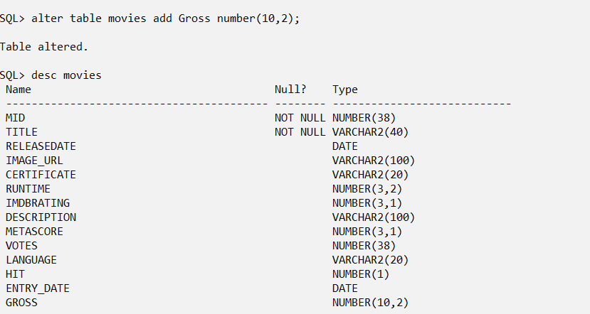

SQL> alter table movies add Gross number(10,2);

Table altered.

SQL> desc movies
Name Null? Type
----------------------------------------- -------- ----------------------------
MID NOT NULL NUMBER(38)
TITLE NOT NULL VARCHAR2(40)
RELEASEDATE DATE
IMAGE_URL VARCHAR2(100)
CERTIFICATE VARCHAR2(20)
RUNTIME NUMBER(3,2)
IMDBRATING NUMBER(3,1)
DESCRIPTION VARCHAR2(100)
METASCORE NUMBER(3,1)
VOTES NUMBER(38)
LANGUAGE VARCHAR2(20)
HIT NUMBER(1)
ENTRY_DATE DATE
GROSS NUMBER(10,2)

- Change the name of the column ‘R_date’ in Movies table to Releasedate. Releasedate must be less than or equal to current systems date(year).

SQL> alter table movies rename column R_date to Releasedate;

Table altered.
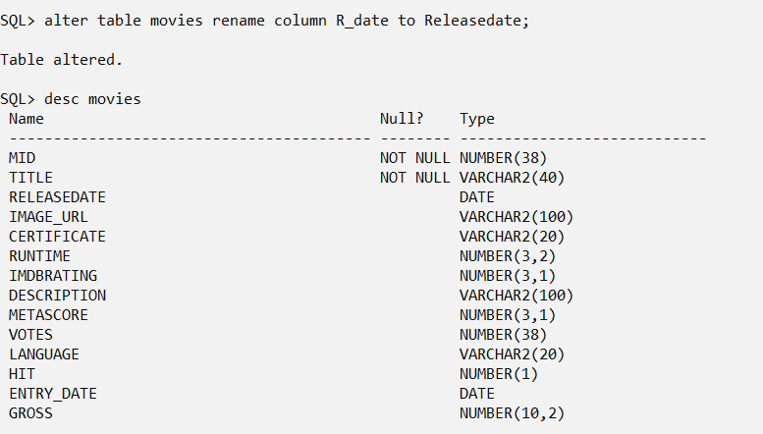

alter table movies add check(Releasedate <= TRUNC(SYSDATE));
- Add a column ‘Age’ in Directors table as Number.
SQL> alter table directors add age Number(10) check(age>=7);

Table altered.

SQL> desc directors
Name Null? Type
----------------------------------------- -------- ----------------------------
DID NOT NULL NUMBER(38)
NAME NOT NULL VARCHAR2(30)
AGE NUMBER(10)
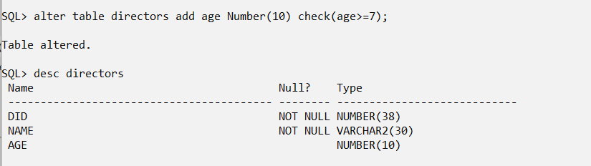

SQL> alter table directors add age Number(10);

Table altered.

SQL> desc directors;
Name Null? Type
----------------------------------------- -------- ----------------------------
DID NOT NULL NUMBER(38)
NAME NOT NULL VARCHAR2(40)
AGE NUMBER(10)

SQL> alter table directors add check(age>=7);

Table altered.
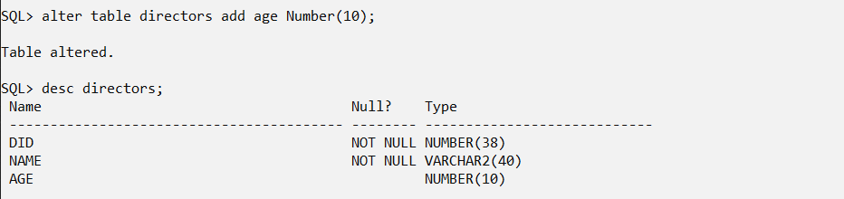

- Add a new column ‘Hit’ with datatype Number(1) and by default 0.

SQL> alter table Movies add hit Number(1) default 0;

Table altered.

SQL> desc movies
Name Null? Type
----------------------------------------- -------- ----------------------------
MID NOT NULL NUMBER(38)
TITLE NOT NULL VARCHAR2(40)
RELEASEDATE DATE
IMAGE_URL VARCHAR2(100)
CERTIFICATE VARCHAR2(20)
RUNTIME NUMBER(3,2)
IMDBRATING NUMBER(3,1)
DESCRIPTION VARCHAR2(100)
METASCORE NUMBER(3,1)
VOTES NUMBER(38)
LANGUAGE VARCHAR2(20)
HIT NUMBER(1)
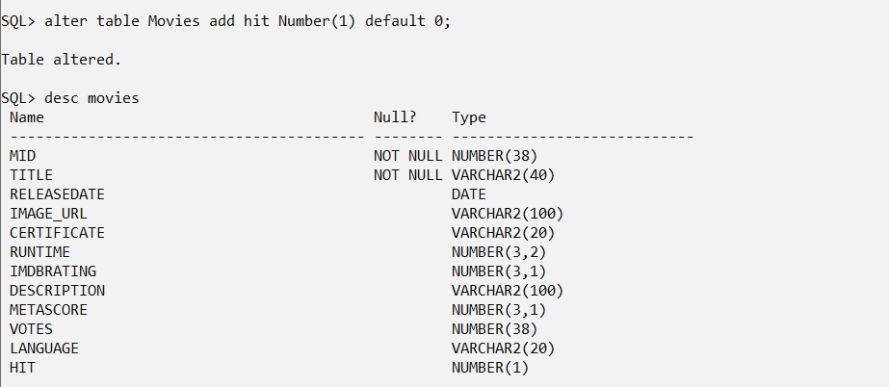

      - Add a new column ‘Entry_date’ in Movies table to record the date on which the movie details are entered in the data base.

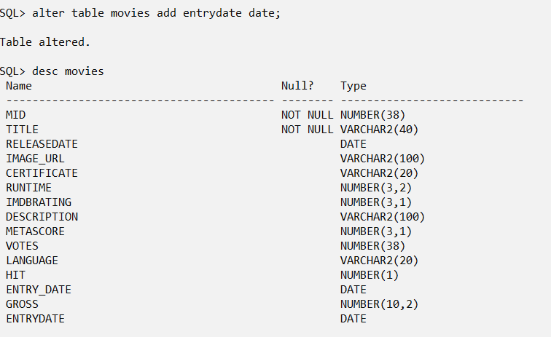

SQL> alter table movies add entrydate date;

Table altered.

SQL> desc movies
Name Null? Type
----------------------------------------- -------- ----------------------------
MID NOT NULL NUMBER(38)
TITLE NOT NULL VARCHAR2(40)
RELEASEDATE DATE
IMAGE_URL VARCHAR2(100)
CERTIFICATE VARCHAR2(20)
RUNTIME NUMBER(3,2)
IMDBRATING NUMBER(3,1)
DESCRIPTION VARCHAR2(100)
METASCORE NUMBER(3,1)
VOTES NUMBER(38)
LANGUAGE VARCHAR2(20)
HIT NUMBER(1)
ENTRY_DATE DATE
GROSS NUMBER(10,2)
ENTRYDATE DATE

- Destroy the table MoviesStars and recreate it.

SQL> drop table Moviesstars;

Table dropped.

SQL> create table MoviesStars(mid int references movies(mid), sid int references stars(sid),primary key(mid,sid));

Table created.

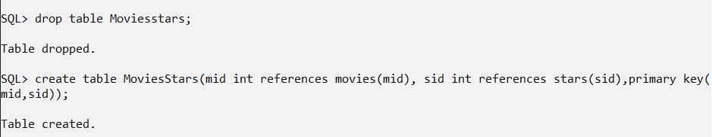
- Change the size of Director’s name to 30.

SQL> alter table directors modify name varchar2(30);

Table altered.

SQL> desc directors;
Name Null? Type
----------------------------------------- -------- ----------------------------
DID NOT NULL NUMBER(38)
NAME NOT NULL VARCHAR2(30)
AGE NUMBER(10)
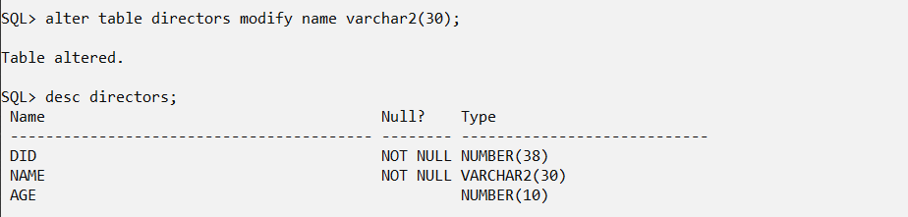
- Add the following check constraints:
  - Release_date should be less than the Entry_date in the Movies table.

SQL> alter table movies add check(releasedate<entry_date);

Table altered.
.
  - Language of movies should be Malayalam, English, Tamil or Hindi.

SQL> alter table movies add check(language in('Malayalam','English','Hindi','Tamil'));

Table altered.

SQL> alter table movies add check(language in('Malayalam','English','Hindi'));

Table altered.

- Practice SQL Data Manipulation Language (DML) commands
  - Row insertion, deletion and updating
- Insert the appropriate data (10 rows) for the tables with respect to defined datatypes, size and constraints.

SQL> insert into movies values(101,'Inception','16-Jul-2010','http://www.movieimage.com/_Inception','PG-13',2.47,8.8,'Mind-bending thriller',74,2046235,'English',1,'01-Jan-2011',12345678.12);

1 row created.

SQL> insert into movies values(102,'Mayaanadhi','22-Dec-2022','http://www.movieimage.com/mayanadhi','U/A',2.27,8,'Romantic Drama',75,20900,'Malayalam',1,'01-Jan-2023',52345678);

1 row created.

SQL> insert into movies values(103,'Oppam','08-Sep-2016','http://www.movieimage.com/oppam','U',2.62,7.5,'Crime Thriller',70,10545,'Malayalam',0,'01-Dec-2016',1500000);

1 row created.

SQL> insert into movies values(104,'Avatar','18-Dec-2020','http://www.movieimage.com/_avatar','PG-13',2.7,7.8,'Epic sci-fi adventure',83,1181175,'English',1,'01-Sep-2021',211787.97);

1 row created.

SQL> insert into movies values(105,'Daddy Cool','14-Aug-2009','http://example.com/daddy_cool.jpg','U',3,5.8,'A quirky family comedy with a touch of mystery',5.6,4200,'Malayalam',1,'07-Sep-2009',5330000);

1 row created.

SQL> insert into movies values(106,'The Avengers','04-May-2012','http://www.movieimage.com/_avengers','PG-13',2.38,8,'Superhero ensemble',69,1353551,'English',0,'01-Sep-2013',621518.81);

1 row created.

SQL> insert into movies values(107,'Pulp Fiction','14-Oct-1994','http://www.movieimage.com/_4','R',2.57,8.9,'Quirky crime film',94,1900251,'English',1,'01-Sep-1995',5111213.93);

1 row created.

SQL> insert into movies values(109,'Lucifer','28-Mar-2019','http://example.com/lucifer.jpg','PG-13',2.5,8.5,'A political thriller with unexpected twists',8.2,32000,'Malayalam',1,'30-Mar-2019',515000);

1 row created.

SQL> insert into movies values(110,'Forrest Gump','06-Jul-1994','http://www.movieimage.com/_6','PG-13',2.37,8.8,'Heartwarming drama',82,2176822,'English',0,'01-Sep-1995',67811.18);

1 row created.

SQL> insert into movies values(108,'Master','23-Jan-2023','http://example.com/movie2.jpg','R',2,6.9,'A suspenseful thriller that takes place under the cover of darkness.',7.5,9872,'Hindi',0,'29-Aug-2023',31500.5);

1 row created.

SQL> insert into movies values(108,'Master','23-Jan-2023','http://example.com/movie2.jpg','R',2,6.9,'A suspenseful thriller that takes place under the cover of darkness.',7.5,9872,'Hindi',0,'29-Aug-2023',31500.5);

1 row created.
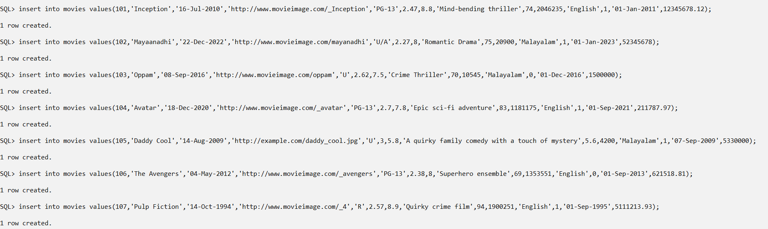
SQL> insert into movies values(101,'Inception','16-Jan-2020','http://www.movieimage.com/_Inception' ,'PG-13',2.47,8.8,'Mind-bending thriller',74,95,'01-Jun-2020','English',1,12345678.12);

1 row created.

SQL> insert into movies values(102,'Mayaanadhi','22-Dec-2022','http://www.movieimage.com/mayanadhi' ,'U/A',1.27,6.4,'Romantic Drama',75,94,'01-Jan-2023','Malayalam',1,5234500678);

1 row created.

SQL> insert into movies values(103,'Oppam','16-Jun-2020','http://www.movieimage.com/oppam' ,'U',2.62,7.5,'Crime Thriller',90,93,'01-Dec-2020','Malayalam',0,1500000);

1 row created.

SQL> insert into movies values(104,'Avatar','16-Jun-2020','http://www.movieimage.com/_avatar' ,'PG-13',2.7,5.9,'Epic sci-fi adventure',83,91,'01-Sep-2021','English',1,211787.97);

1 row created.

SQL> insert into movies values(105,'Daddy Cool','14-Feb-2009','http://example.com/daddy_cool.jpg' ,'U',3,5.8,'A quirky family comedy with a touch of mystery',5.6,89,'07-Sep-2009','Malayalam',1,650030000);

1 row created.

SQL> insert into movies values(106,'The Avengers','04-May-2012','http://www.movieimage.com/_avengers' ,'PG-13',2.38,8,'Superhero ensemble',69,90,'01-Sep-2013','English',0,621518.81);

1 row created.

SQL> insert into movies values(107,'Pulp Fiction','14-Feb-2020','http://www.movieimage.com/_4' ,'R',2.57,8.9,NULL,94,78,'01-Sep-2020','English',1,5111213.93);

1 row created.

SQL> insert into movies values(108,'Master','23-Jan-2023','http://example.com/movie2.jpg' ,'R',2,6.9,'A suspenseful thriller that takes place under the cover of darkness.',7.5,45,'29-Aug-2023','Tamil',0,31500.5);

1 row created.

SQL> insert into movies values(109,'Lucifer','28-Mar-2020','http://example.com/lucifer.jpg' ,'PG-13',2.5,8.5,'A political thriller with unexpected twists',8.2,34,'30-Mar-2020','Malayalam',1,515000);

1 row created.

SQL> insert into movies values(110,'Oppenheimer','21-Feb-2023','http://example.com/openhei.jpg' ,'R',2.75,8.1,NULL,40,96,'25-Jul-2023','English',1,505000000);

1 row created.

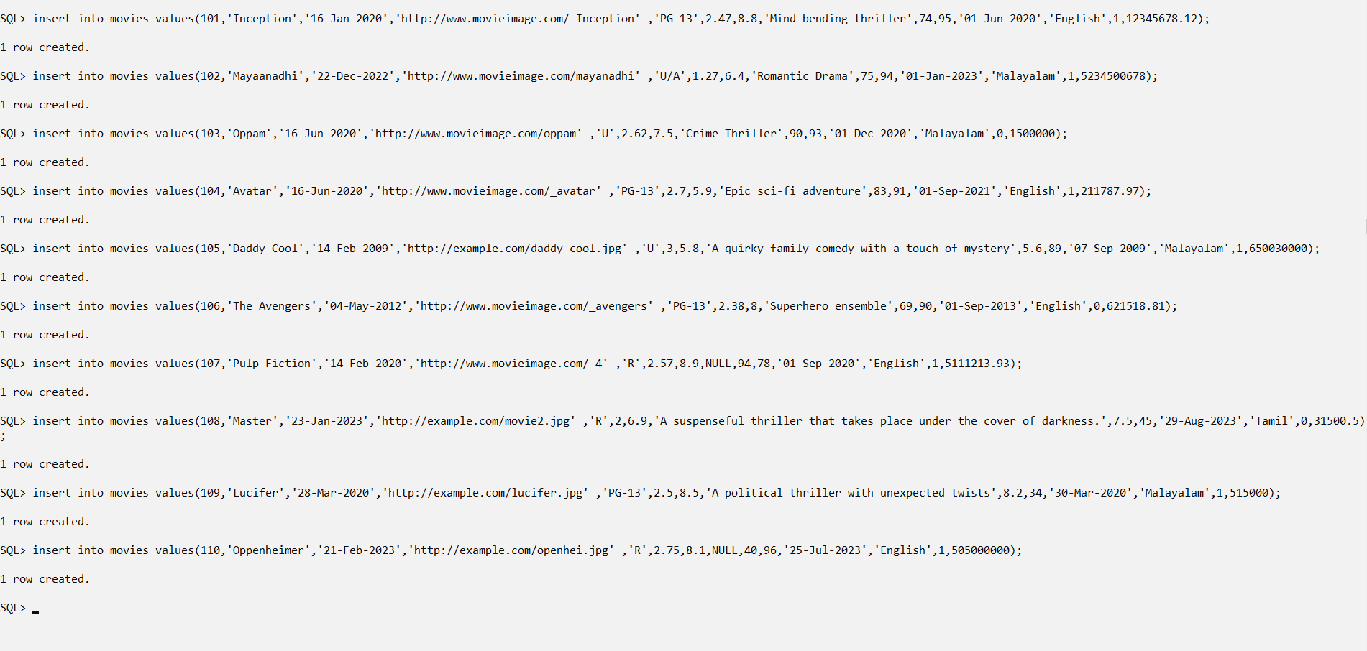
SQL> insert into directors values(115,'Priyadarshan',64);

1 row created.

SQL> insert into directors values(116,'Lijo Jose Pellissery',42);

1 row created.

SQL> insert into directors values(117,'Aashiq Abu',42);

1 row created.

SQL> insert into directors values(118,'Christopher Nolan',51);

1 row created.

SQL> insert into directors values(119,'Steven Spielberg',75);

1 row created.

SQL> insert into directors values(126,'Prithviraj Sukumaran',42);

1 row created.

SQL> insert into directors values(121,'Martin Scorsese',79);

1 row created.

SQL> insert into directors values(122,'Ridley Scott',83);

1 row created.

SQL> insert into directors values(125,'Lokesh Kanagaraj',35);

1 row created.

SQL> insert into directors values(124,'Robert Zemeckis',70);

1 row created.
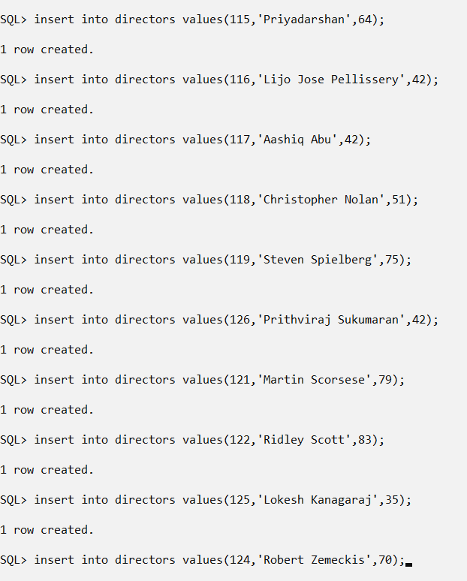

SQL> insert into stars values(301,'Mohanlal','Legendary Malayalam actor','21-May-1960');

1 row created.

SQL> insert into stars values(302,'Zoe Saldana','Hollywood actor','05-May-1964');

1 row created.

SQL> insert into stars values(303,'Prithviraj','Versatile actor','16-Oct-1982');

1 row created.

SQL> insert into stars values(304,'Tovino Thomas','Acclaimed actor','08-Aug-1982');

1 row created.

SQL> insert into stars values(305,'Leonardo DiCaprio','Award-winning actor','11-Nov-1974');

1 row created.

SQL> insert into stars values(306,'Robert Downey Jr.','Iron Man','04-Apr-1965');

1 row created.

SQL> insert into stars values(307,'Vijay','Popular Tamil actor','22-Jun-1974');

1 row created.

SQL> insert into stars values(308,'Emma Watson','Hermione Granger','15-Apr-1990');

1 row created.

SQL> insert into stars values(309,'Sreenath Bhasi','Malayalam actor','04-May-1985');

1 row created.

SQL> insert into stars values(310,'Mammootty','Iconic Malayalam actor','07-Sep-1951');

1 row created.

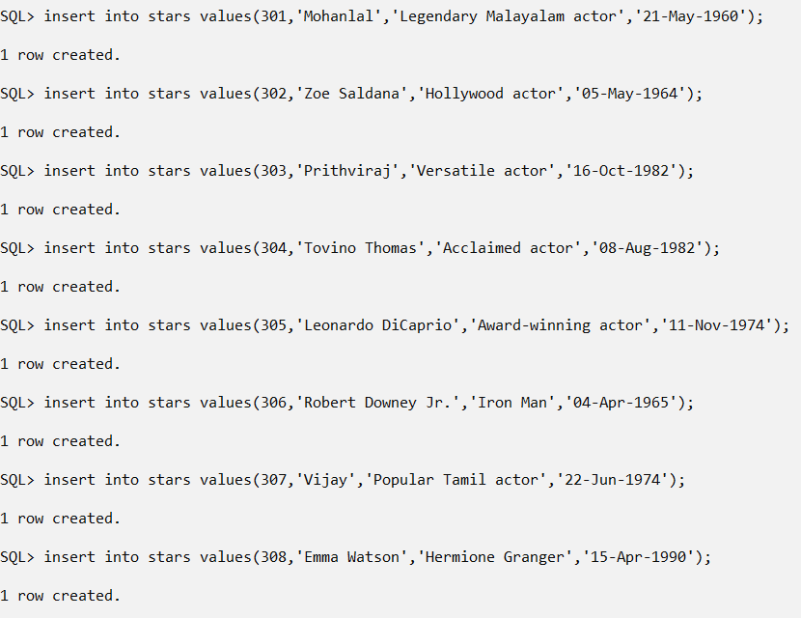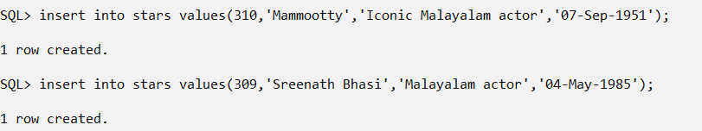

SQL> insert into moviesstars values(101,305);

1 row created.

SQL> insert into moviesstars values(102,304);

1 row created.

SQL> insert into moviesstars values(103,301);

1 row created.

SQL> insert into moviesstars values(104,302);

1 row created.

SQL> insert into moviesstars values(105,310);

1 row created.

SQL> insert into moviesstars values(106,306);

1 row created.

SQL> insert into moviesstars values(107,305);

1 row created.

SQL> insert into moviesstars values(108,307);

1 row created.

SQL> insert into moviesstars values(109,303);

1 row created.

SQL> insert into moviesstars values(109,301);

1 row created.

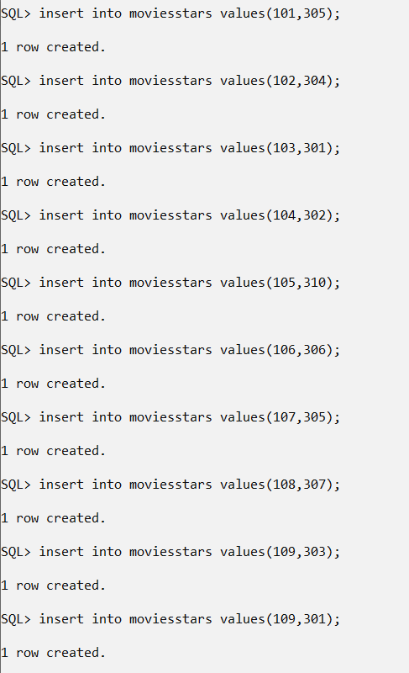

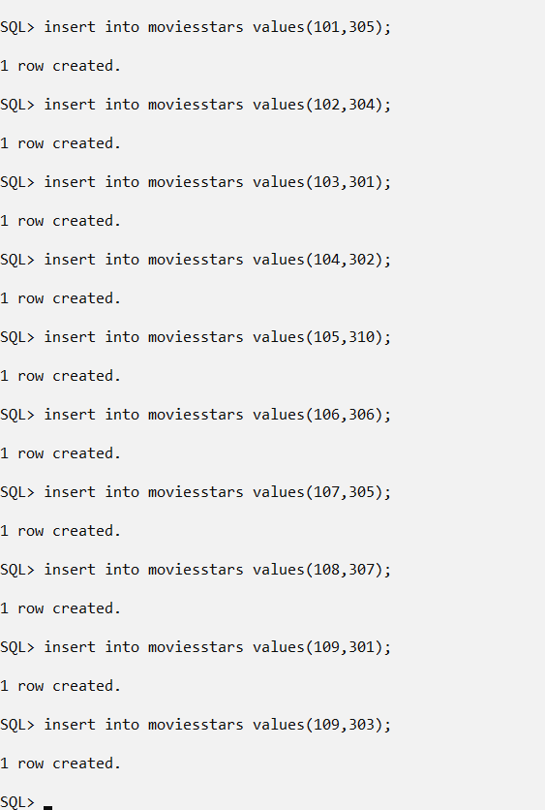

SQL> insert into moviesdirectors values(101,118);

1 row created.

SQL> insert into moviesdirectors values(102,117);

1 row created.

SQL> insert into moviesdirectors values(103,115);

1 row created.

SQL> insert into moviesdirectors values(104,118);

1 row created.

SQL> insert into moviesdirectors values(105,117);

1 row created.

SQL> insert into moviesdirectors values(106,124);

1 row created.

SQL> insert into moviesdirectors values(107,122);

1 row created.

SQL> insert into moviesdirectors values(108,125);

1 row created.

SQL> insert into moviesdirectors values(109,126);

1 row created.

SQL> insert into moviesdirectors values(110,121);

1 row created.

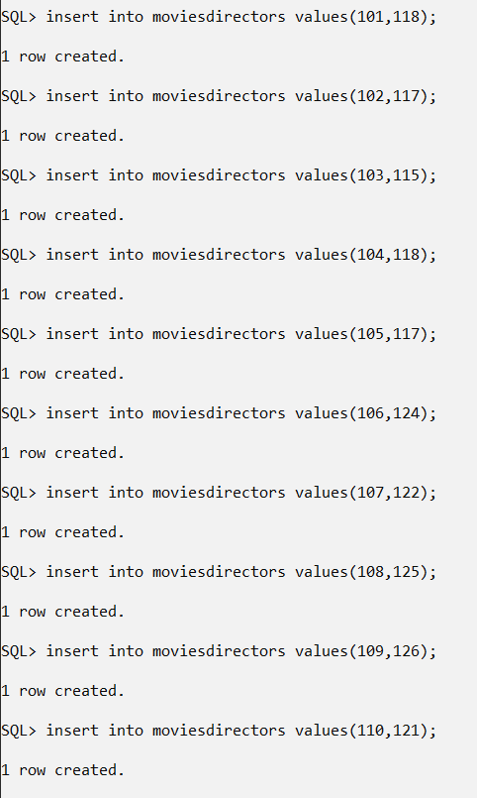
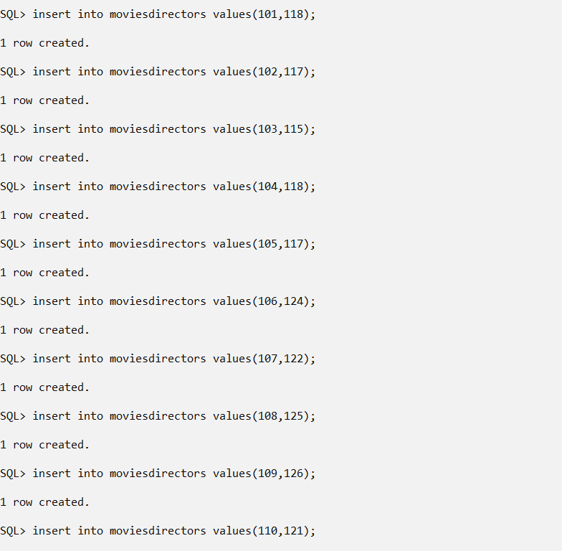

- Change value of Hit to 1 where ‘Votes’ greater than or equal to 90.

SQL> update movies set hit=1 where votes>=90;

10 rows updated.
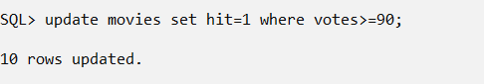
- Create table IndustryHit with the following columns:
Id
Title
Year
Language
Votes
Gross

The data types and null characteristics for these columns should be
the same as the corresponding columns in the Movies table
described at the beginning of the lab exercise.

SQL> create table IndustryHit(mid int primary key, title varchar2(40) not null, ReleaseDate date, Language varchar2(20),Votes Number(38),Gross Number(10,2));

Table created.

SQL> desc IndustryHit;
Name Null? Type
----------------------------------------- -------- ----------------------------
MID NOT NULL NUMBER(38)
TITLE NOT NULL VARCHAR2(40)
RELEASEDATE DATE
LANGUAGE VARCHAR2(20)
VOTES NUMBER(38)
GROSS NUMBER(10,2)
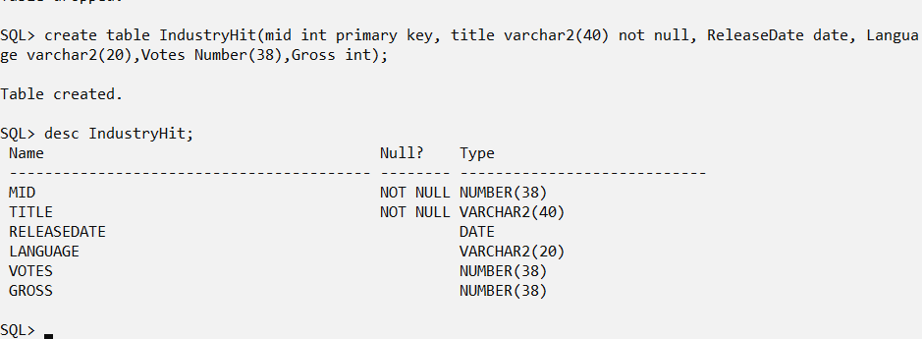

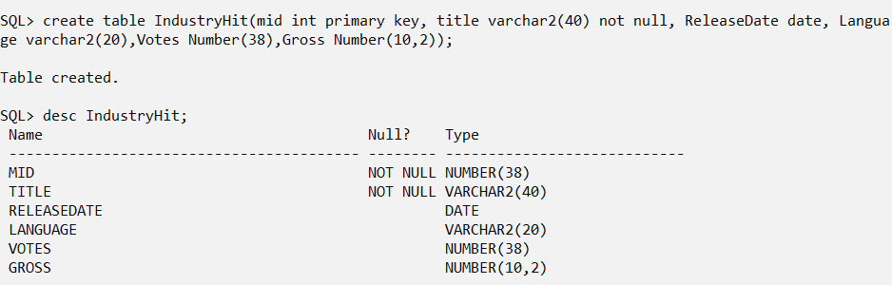

- New movies hit the box office, their data is as follows:
Id: 1014, 1021, 1032
Title: 2018: Everyone is a Hero, Oppenheimer, Maamannan
Year: 2023, 2023, 2023
Language: Malayalam, English, Tamil
Votes: 97, 96, 95
Gross: 750000000 , 500000000, 505000000
Add the new employees to the IndustryHit table.
- Insert data into the new IndustryHit table.

SQL> Insert into IndustryHit values(1014,'Everyone is a hero','5-may-2023','Malayalam',97,750000000);

1 row created.

SQL> Insert into IndustryHit values(1021,'Oppenheimer','21-Jul-2023','English',96,500000000);

1 row created.

SQL> Insert into IndustryHit values(1032,'Maamannan','29-Jun-2023','Tamil',95,505000000);

1 row created.
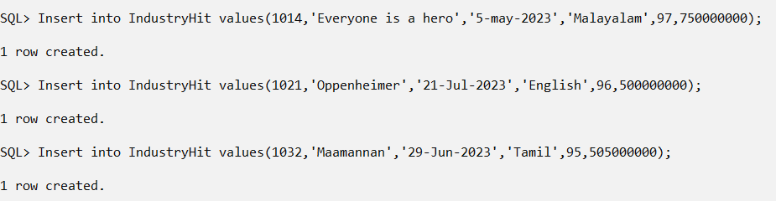

SQL> insert into IndustryHit values(1056,'PuliMurugan','27-Oct-2023','Malayalam',98,625000000);

1 row created.

SQL> insert into IndustryHit values(1011,'Gulmohar','25-May-2023','Hindi',95,504010000);

1 row created.

SQL> insert into IndustryHit values(1051,'Maari','09-Jan-2023','Tamil',97,514350000);

1 row created.

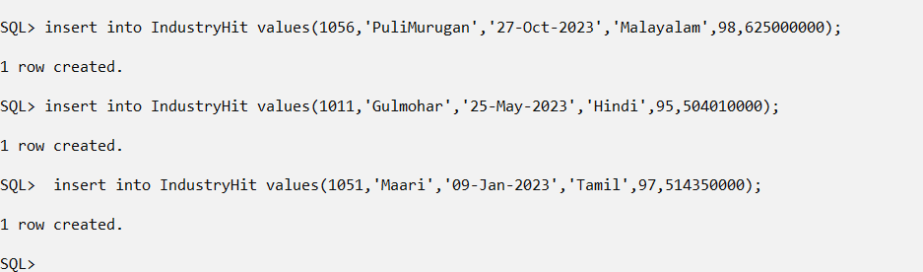
- Insert data into the IndustryHit table by copying the appropriate columns in the Movies table for those Movies that have Votes greater than or equal to 95.

SQL> Insert into IndustryHit select mid,title,releasedate,language,votes,gross from movies where votes>=95;

2 rows created.
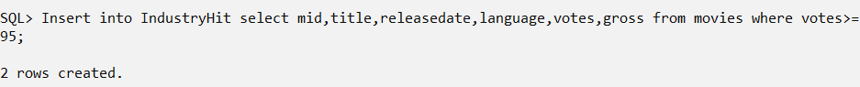

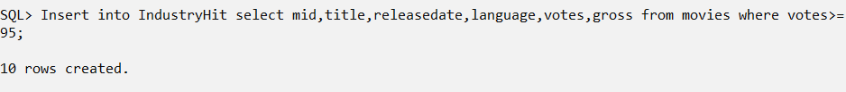
- Movie Oppenheimer got a Metascore of 80. Make the appropriate data change.

SQL> update movies set metascore=80 where title='Oppenheimer';

1 row updated.
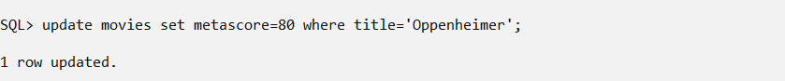
- Delete all movies whose Metascore is less than 50.

SQL> delete from movies where metascore<50

- Movie ‘Voice Of Sathyanathan’ was released.
For ‘Voice Of Sathyanathan’ enter the following data:
Id : 1015
Title: Voice Of Sathyanathan
Year: 2023
Image_url: https://m.media-amazon.com/imak2M_.jpg
Certificate: U
Runtime: 2.10
ImdbRating: 7.4
Description: A man's life becomes increasingly complicated after his neighbor is injured in a dispute over a fence.
Metascore: 60
Votes: 90
Gross: 109500000
SQL> insert into movies values(1015,'Voice Of Sathyanathan','29-Jul-2023','https://m.media-amazon.com/imak2M_.jpg','U',2.10,7.4,'A mans life becomes increasingly complicated after his neighbor is injured in a dispute over a fence',60,90,'01-Sep-2023','Malayalam',1,109500000);

1 row created.
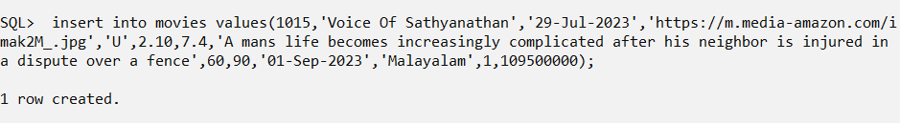

- Delete all rows from IndustryHit and drop the IndustryHit table.
SQL> delete from industryhit;

8 rows deleted.

SQL> drop table industryhit;

Table dropped.
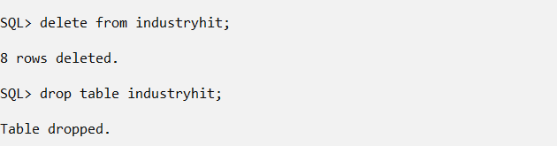

  - Retrieval of data (Simple select query and select with ‘where’
options (include all relational and logical operators)
- List details of all movies
SQL> select * from movies;

MID TITLE RELEASEDA IMAGE_URL CERTIFICATE RUNTIME IMDBRATING DESCRIPTION METASCORE VOTES ENTRYDATE LANGUAGE HIT GROSS
---------- ---------------------------------------- --------- ---------------------------------------------------------------------------------------------------- -------------------- ---------- ---------- ---------------------------------------------------------------------------------------------------- ---------- ---------- --------- -------------------- ---------- ----------
1015 Voice Of Sathyanathan 29-JUL-23 https://m.media-amazon.com/imak2M_.jpg U 2.1 7.4 A mans life becomes increasingly complicated after his neighbor is injured in a dispute over a fence 60 90 01-SEP-23 Malayalam 1 109500000
101 Inception 16-JAN-20 http://www.movieimage.com/_Inception PG-13 2.47 8.8 Mind-bending thriller 74 95 01-JUN-20 English 1 12345678
102 Mayaanadhi 22-DEC-22 http://www.movieimage.com/mayanadhi U/A 1.27 6.4 Romantic Drama 75 94 01-JAN-23 Malayalam 1 5234500678
103 Oppam 16-JUN-20 http://www.movieimage.com/oppam U 2.62 7.5 Crime Thriller 90 93 01-DEC-20 Malayalam 1 1500000
104 Avatar 16-JUN-20 http://www.movieimage.com/_avatar PG-13 2.7 5.9 Epic sci-fi adventure 83 91 01-SEP-21 English 1 211788
105 Daddy Cool 14-FEB-09 http://example.com/daddy_cool.jpg U
3 5.8 A quirky family comedy with a touch of mystery 5.6 89 07-SEP-09 Malayalam 1 650030000
106 The Avengers 04-MAY-12 http://www.movieimage.com/_avengers PG-13 2.38 8 Superhero ensemble 69 90 01-SEP-13 English 1 621519
107 Pulp Fiction 14-FEB-20 http://www.movieimage.com/_4 R 2.57 8.9 94 78 01-SEP-20 English 1 5111214
108 Master 23-JAN-23 http://example.com/movie2.jpg R
2 6.9 A suspenseful thriller that takes place under the cover of darkness. 7.5 45 29-AUG-23 Tamil 0
31501
109 Lucifer 28-MAR-20 http://example.com/lucifer.jpg PG-13 2.5 8.5 A political thriller with unexpected twists 8.2 34 30-MAR-20 Malayalam 1 515000
110 Oppenheimer 21-FEB-23 http://example.com/openhei.jpg R 2.75 8.1 80 96 25-JUL-23 English 1 505000000

11 rows selected.
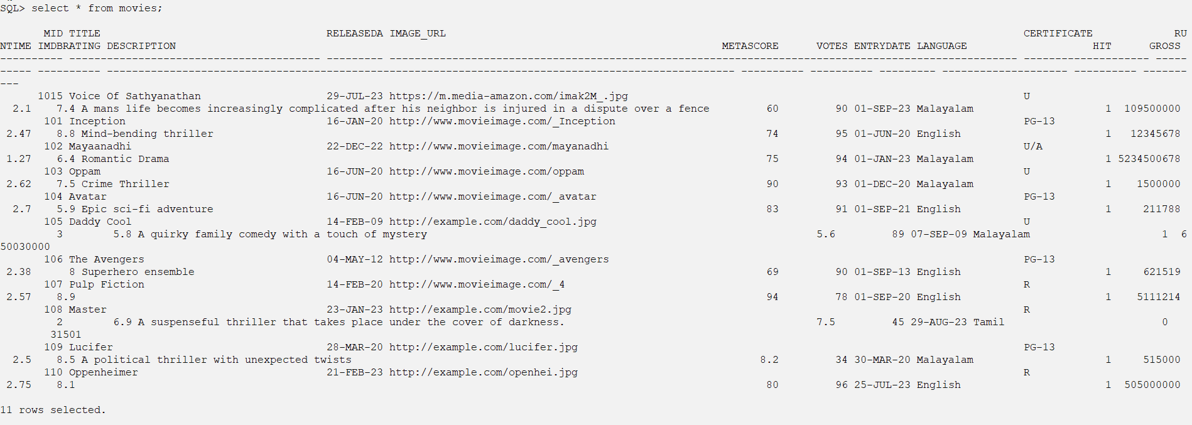
- List Title, Votes, Releasedate, Gross where Gross collection greater than 5000,000,00. Sequence the results in descending order by Gross.

SQL> select title,votes,releasedate,gross from movies where gross>=500000000 order by gross desc;

TITLE VOTES RELEASEDA GROSS
---------------------------------------- ---------- --------- ----------
Mayaanadhi 94 22-DEC-22 5234500678
Daddy Cool 89 14-FEB-09 650030000
Oppenheimer 96 21-FEB-23 505000000
SQL>
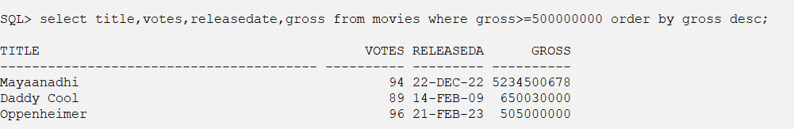
- Retrieve the titles and years of Tamil movies released in 2022.

SQL> select title,releasedate,entrydate from movies where language='Tamil';

TITLE RELEASEDA ENTRYDATE
---------------------------------------- --------- ---------
Master 23-JAN-23 29-AUG-23
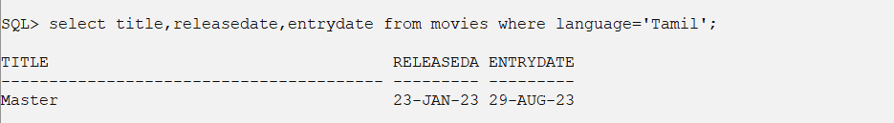
SQL> select title,releasedate,entrydate from movies where language='Tamil' AND EXTRACT(YEAR FROM releasedate) = 2022;

no rows selected
- Get the titles, years, and meta scores of movies sorted in descending order of meta scores.seelct
SQL> select title,releasedate,metascore from movies order by metascore desc;

TITLE RELEASEDA METASCORE
---------------------------------------- --------- ----------
Pulp Fiction 14-FEB-20 94
Oppam 16-JUN-20 90
Avatar 16-JUN-20 83
Oppenheimer 21-FEB-23 80
Mayaanadhi 22-DEC-22 75
Inception 16-JAN-20 74
The Avengers 04-MAY-12 69
Voice Of Sathyanathan 29-JUL-23 60
Lucifer 28-MAR-20 8.2
Master 23-JAN-23 7.5
Daddy Cool 14-FEB-09 5.6

11 rows selected.
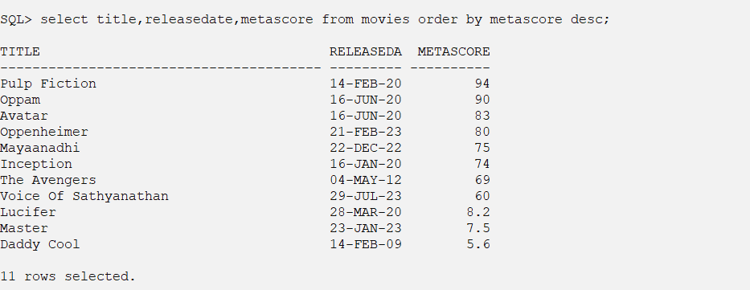
- List titles, years, languages, dates and votes of all Malayalam and English movies released before 2022 and ImdbRating less than 7. The list should be ordered by Title.

SQL> select title,releasedate,language,entrydate,votes from movies where language in ('Malayalam','English') and releasedate<'01-Jan-2022' and IMDBRATING<7 order by title;

TITLE RELEASEDA LANGUAGE ENTRYDATE VOTES
---------------------------------------- --------- -------------------- --------- ----------
Avatar 16-JUN-20 English 01-SEP-21 91
Daddy Cool 14-FEB-09 Malayalam 07-SEP-09 89
- List all the movies whose title starts with ‘Open’. Order the result by descending order of their id.
SQL> select mid, title from movies where title like 'Oppen%' order by mid;

MID TITLE
---------- ----------------------------------------
110 Oppenheimer
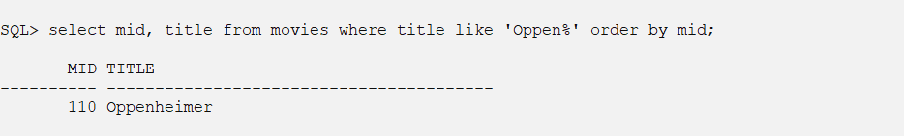
- List Hit movies released in 2022 and 2023. Order the result by ascending order of their Titles.
a SQL> select * from movies where hit=1 and EXTRACT(YEAR FROM releasedate) IN (2022, 2023) order by title;

MID TITLE RELEASEDA IMAGE_URL CERTIFICATE RUNTIME IMDBRATING DESCRIPTION METASCORE VOTES ENTRYDATE LANGUAGE HIT GROSS
---------- ---------------------------------------- --------- ---------------------------------------------------------------------------------------------------- -------------------- ---------- ---------- ---------------------------------------------------------------------------------------------------- ---------- ---------- --------- -------------------- ---------- ----------
102 Mayaanadhi 22-DEC-22 http://www.movieimage.com/mayanadhi U/A 1.27 6.4 Romantic Drama 75 94 01-JAN-23 Malayalam 1 5234500678
110 Oppenheimer 21-FEB-23 http://example.com/openhei.jpg R 2.75 8.1 80 96 25-JUL-23 English 1 505000000
1015 Voice Of Sathyanathan 29-JUL-23 https://m.media-amazon.com/imak2M_.jpg U 2.1 7.4 A mans life becomes increasingly complicated after his neighbor is injured in a dispute over a fence 60 90 01-SEP-23 Malayalam 1 109500000

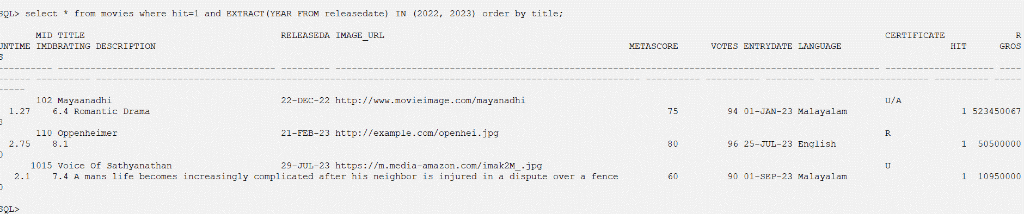
- Retrieve movies with a runtime between 1.5 and 2.5 hours.
a SQL> select * from movies where runtime between 1.5 and 2.5;

MID TITLE RELEASEDA IMAGE_URL CERTIFICATE RUNTIME IMDBRATING DESCRIPTION METASCORE VOTES ENTRYDATE LANGUAGE HIT GROSS
---------- ---------------------------------------- --------- ---------------------------------------------------------------------------------------------------- -------------------- ---------- ---------- ---------------------------------------------------------------------------------------------------- ---------- ---------- --------- -------------------- ---------- ----------
1015 Voice Of Sathyanathan 29-JUL-23 https://m.media-amazon.com/imak2M_.jpg U 2.1 7.4 A mans life becomes increasingly complicated after his neighbor is injured in a dispute over a fence 60 90 01-SEP-23 Malayalam 1 109500000
101 Inception 16-JAN-20 http://www.movieimage.com/_Inception PG-13 2.47 8.8 Mind-bending thriller 74 95 01-JUN-20 English 1 12345678
106 The Avengers 04-MAY-12 http://www.movieimage.com/_avengers PG-13 2.38 8 Superhero ensemble 69 90 01-SEP-13 English 1 621519
108 Master 23-JAN-23 http://example.com/movie2.jpg R
2 6.9 A suspenseful thriller that takes place under the cover of darkness. 7.5 45 29-AUG-23 Tamil 0
31501
109 Lucifer 28-MAR-20 http://example.com/lucifer.jpg PG-13 2.5 8.5 A political thriller with unexpected twists 8.2 34 30-MAR-20 Malayalam 1 515000

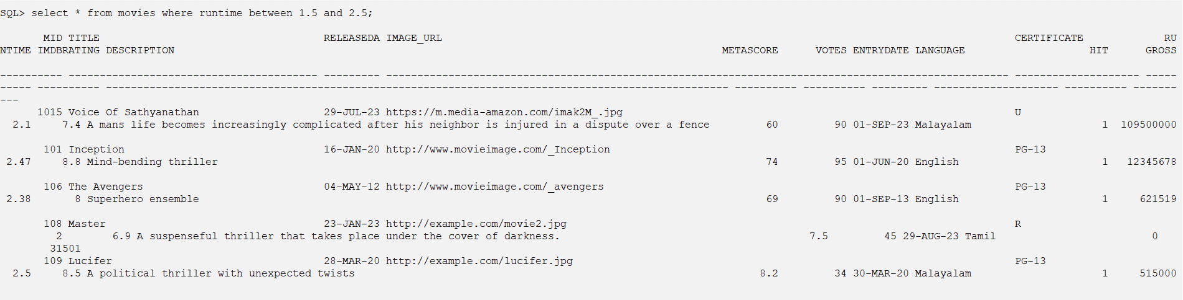
- Retrieve movies with Metascore ratings below 50 and IMDb ratings above 6.0.
a SQL> select mid,title,metascore,imdbrating from movies where metascore <50 and imdbrating>6;

MID TITLE METASCORE IMDBRATING
---------- ---------------------------------------- ---------- ----------
108 Master 7.5 6.9
109 Lucifer 8.2 8.5
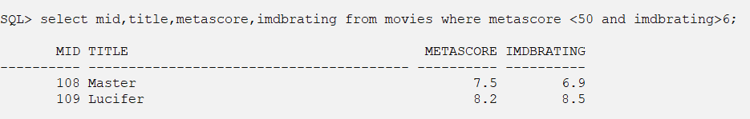
- Retrieve movies with no description provided.
b SQL> select * from movies where description is NULL;

MID TITLE RELEASEDA IMAGE_URL CERTIFICATE RUNTIME IMDBRATING DESCRIPTION METASCORE VOTES ENTRYDATE LANGUAGE HIT GROSS
---------- ---------------------------------------- --------- ---------------------------------------------------------------------------------------------------- -------------------- ---------- ---------- ---------------------------------------------------------------------------------------------------- ---------- ---------- --------- -------------------- ---------- ----------
107 Pulp Fiction 14-FEB-20 http://www.movieimage.com/_4 R 2.57 8.9 94 78 01-SEP-20 English 1 5111214
110 Oppenheimer 21-FEB-23 http://example.com/openhei.jpg R 2.75 8.1 80 96 25-JUL-23 English 1 505000000
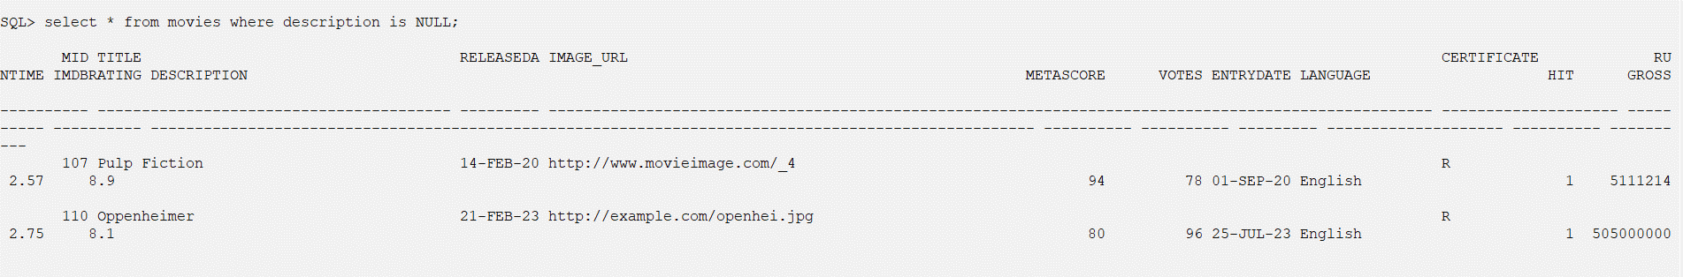

  - Functions: Numeric Data, Character Conversion and Group functions
  - Data manipulations using date functions
  - Set Operations
  - Illustration of Group By having clause

3.8 Views
- Create a view called MovieDetails that combines information from the Movies, Directors, and Stars tables to display movie titles, directors' names, and the names of stars who acted in those movies.

- Create a view called HighlyRatedMovies that displays movies with IMDb ratings greater than 8.0, including their titles and ratings.
- Create a view called DirectorMovies that provides a list of directors along with the number of movies they have directed.
- Create a view called StarMovies that displays stars' names and the titles of movies they have acted in.
- Create a view called LongestMovies that lists the titles of movies with the longest runtimes (duration).
- Create a view called LanguageDistribution that shows the distribution of movies based on the languages they were released in, including the count of movies for each language.
- Create a view called GrossEarnings that displays movies with their titles and gross earnings, sorted by earnings in descending order.
- Create a view called IndustryHitMovies that shows the titles and release dates of industry hit movies.
- Create a view called MovieVotes that displays movies along with their titles and the number of votes they have received.
- Create a view called CertifiedMovies that lists movies with their titles and certificates (e.g., U/A, U).

4.0 Practice PL/SQL
4.1 Introduction to PL/SQL
- Write a PL/SQL code block to calculate the area of a circle for a value of radius varying from 3 to 7. Store the radius and corresponding values of calculated area in an empty table named Areas, consisting of two columns Radius and Area.
- Write a PL/SQL block of code for inverting a number accepted from the console.
- Write a PL/SQL code block that will accept an account number from the user and debit an amount of Rs.2000 from the account if the account has a minimum balance of 500 after the amount is debited. The process is fired on the Accounts table.
- Write a PL/SQL block of code that updates the salaries of Maria Jacob and Albert by Rs. 2000/- and Rs.2500/- respectively. Then check to see that the total salary does not exceed 75000. If the total salary is greater than 75000, then undo the updates made to salaries of both. (Use savepoint, rollback and commit).
4.2 Illustration of Cursors
Illustration of Implicit cursor.
- Write a PL/SQL block to accept an employee number and update the salary of that employee to raise the salary by 0.15. Display appropriate message based on the existence of the record in the employee table.
- The HRD manager decides to raise the salary of employees working as ‘analyst’ by 0.15. Write a cursor to update the salary of the employees. Display the no. of employee records that has been modified.
Illustration of explicit cursor.
- Write an explicit cursor to display the name,department, salary of the first 5 employees getting the highest salary.
- The HRD manager decides to raise the salary of employees working as ‘analyst’ by 0.15. Whenever any such raise is given to the employees, a record for the same is maintained in the emp_raise table. It includes the employee number, the date when the raise was given and actual raise. Write a PL/SQL block to update the salary of the employees and insert a record in the emp_raise table.

Emp_raise(empcode, raisedate,raise_amt)

